Вести от фермеров Айовы (Дейвид Миллер)
август 2013 года

Поездка на Украину произвела впечатление на группу членов ФармБюро штата Айова

ФармБюро штата Айова в июне-июле с.г. организовала ознакомительную поездку в Черноморский регион. Целью поездки было знакомство с состоянием сельского хозяйства Украины и Румынии и оценка перспектив этих стран как потенциальных соперников на мировых с/х рынках.

В делегации было 17 фермеров и три сотрудника головного офиса ФармБюро. Мы проехали 2 тысячи километров по дорогам Украины и Румынии, посещая фермы, зернохранилища, морские порты, а также общаясь с многими и многими людьми.

В этом письме я поделюсь с вами нашими мыслями по результатам поездки.

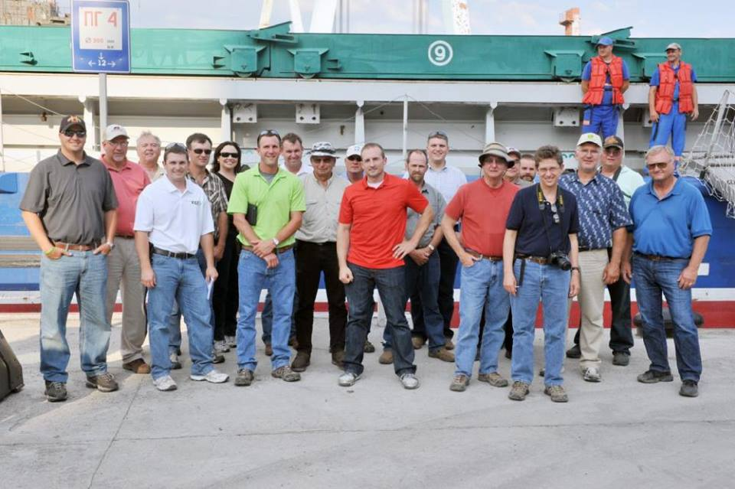

Сельское хозяйство на Украине имеет огромный потенциал, благодаря блвгодатной почве и зарубежным инвестициям, которые щедро текут туда. Это оценка была дана официальными представителями Министерства с/х США, которые работают в Посольстве США в Киеве. Хотя они также поделились с нами, что страну ожидают и большие решения, от которых не уйти. Такими решениями, по нашему мнению, станут дилеммы по структуре ферм, по выбору культур и применяемым технологиям, а также принятие решений по итеграции: пойдет ли она в сторону Запада или в сторону России. Сотрудники посольства сказали нам, что от решения этих вопросов будет зависеть будущее украинского сельского хозяйства и тот факт, станет ли она реальным конкурентом для США на мировых рынках зерна, как это сделали Аргентина и Бразилия или нет.

Рэндал Хейгер, - атташе по с/х Посольства США в Киеве, сказал, что структура фермерских хозяйств на Украине является камнем приткновения. «Исторически, Украина поддерживала мелкое крестьянское хозяйство. Они и сейчас много говорят об этом. Однако, реальность такова, что стране нужна валюта и поэтому только большие холдинги обеспечивают украинский экспорт, а значит, - приносят нужные валютные средства в казну».
После распада Советского Союза колхозные и совхозные земли были розданы селянам, но они, в большинстве случаев, сдают эти земли в аренду, и часто с участием зарубежных инвесторов. Однако, корпорациям не разрешено владет землей.

Во время нашего пребывания мы более близко познакомились с фермой, которой управляет Джеф Рехкеммер. Дело в том, что Джеф – Айовский фермер. Каждый год
Iowa farmers visiting Ukraine during the Iowa Farm Bureau’s Black Sea study tour found a lot of things familiar about Jeff Rechkemmer’s farm. Rechkemmer, who splits his time each year between farms in Ukraine and Oelwein, Iowa raises corn, soybeans, wheat and rapeseed and works his fields with John Deere tractors manufactured in Waterloo and dries his crops with a Sukup dryer built in Sheffield, Iowa. But it didn’t take long for the Iowa-based visitors to discover some major differences between their farms and Rechkemmer’s FarmGate Ukraine farm, which he operates in cooperation with investors from the Netherlands.

Rechkemmer farms about 17,000 acres, while the typical Iowa commercial farm is generally less than 2,000 acres. And, Rechkemmer noted, his farm is not large by the standards of what are considered technical farms that have been put together in Ukraine since the early 1990s, when the country became independent from Soviet Union.

Indeed, in the first few days of their tour to learn more about this region emerging as a serious competitor to the United States in world grain markets, the Iowans visited nearby farms that were much larger than Rechkemmer’s operation. And Ukraine’s largest farm is reputed to be 1.7 million acres of tillable land.

A major difference between farms in the United States and Ukraine is the structure of land holdings and the sheer number of landlords. Most Iowa farmers own some of the land they farm and rent more from a few, or maybe even a dozen, landlords. In contrast, Rechkemmer has more than 4,000 landlords for his farm and doesn’t own any of the land he farms. He does own the area where his machinery and grain are kept.

Another contrast is the social responsibilities that Rechkemmer, as the major farmer and employer in his small community, takes on. In the past few years, in addition to providing payments to the village, he has refurbished an aging water tower, graded snowy roads, provided loans and even taken on the task of making sure needed caskets are built for townspeople who have passed away. “It’s just part of what you do to keep everyone happy in the community. The village really relies on us,” Rechkemmer said. It was the added social responsibilities for Ukrainian farmers that caught the attention of the Iowan visitors.

While Ukrainian agriculture has made tremendous progress in the past two decades, there is still a long way to go before it reaches its full potential, Rechkemmer said. There is still some land to be put back into production, although much of the best land has already been rejuvenated from its neglect during the communist era, he said. Perhaps a bigger issue for Ukraine’s farm sector, Rechkemmer said, “is bringing the art of farming and the entrepreneurial spirit in the people. We’ve seen a lot of money invested here and big equipment brought in, but it also takes people who really know how to farm like we have in Iowa and the United States.” And that’s what Rechkemmer hopes he brings to the table with his experience farming in Iowa, as well as Texas, and passion for agriculture.

Another issue for Ukraine is biotech agriculture. While biotech crops are not officially raised in Ukraine, it is estimated that 70 percent of soybeans and 30 percent of corn grown in the country carry genetically modified traits according to a number of people that IFBF tour participants talked to. Ukraine is in discussions for a relationship with the European Union, which hasn’t allowed the biotech crops. At the same time, farmers have seen the effectiveness of the biotech crops that are used widely in the United States.

Conservation issues are also emerging for Ukrainian agriculture, according to Yuliya Dubinyuk, an agriculture specialist for the U.S. Department of Agriculture in Kiev. An example is the concern about growing sunflowers for oil production she said. “Sunflower production is growing because it has been the most profitable crop sold in the world markets,” said Dubinyuk, a Ukraine native who earned her degree at Iowa State University. “But sunflowers are very hard on the soil, and there is some talk in the government about mandating crop rotations.” Vitaly Sabluk of the Ukrainian ag ministry said his country faces a situation much like the United States in terms of conservation. There are some in the country who want to mandate conservation practices, while others believe that farmers will volunteer to do more for conservation because they want to take care of the property they farm.

Bill Horan, a Rockwell City farmer and Calhoun County Farm Bureau member, has a unique perspective as a participant in the Iowa Farm Bureau Federation Black Sea study tour. Horan visited Ukraine before as part of a farmer-to-farmer exchange in 1992, just after the Soviet Union ended. There’s a startling contrast in Ukraine between then and now, the farmer said as the tour bus carrying the Farm Bureau members worked its way through the bustling regional city of Vinnytsya on a weekday morning heading for a day of farm visits. “They have really made an amazing amount of progress in the last 20 years. There is better food, better cars and everything just looks better. In the communist days, they just didn’t fix anything.” While Ukraine still has many issues, its economy is starting to show clear signs of progress. And as the visiting Iowans saw, the country’s agriculture sector is on the move big time. Led by large, highly-technical farms, it is feeding the local population and producing enough to make Ukraine a rising star in the world grain export market.

Farmers on the Iowa Farm Bureau Federation (IFBF) Black Sea study could not help to be impressed by many of the farms they visited in Ukraine and Romania. The Black Sea region farms are big, spreading out thousands and thousands of acres. Many are very technologically advanced, using some of the biggest and most advanced American-built machines in existence. And farmers in the Black Sea area work in an environmental regulatory structure that appears to be less onerous than those faced by Iowa farmers.

But the Iowans on the IFBF study tour said they didn’t feel intimidated about the prospect of competing with the farms in the Black Sea region. They said Iowa farms can remain competitive because most farmers own a portion of their land, have access to very efficient markets and capital, and have the entrepreneurial spirit to continue improving their operations.
“I think that we are way too concerned about size of the fields, and it’s easy to get caught up in it when you see fields that are two miles long,” said Brad Moeckly, a Polk County Farm Bureau member who farms near Elkhart. “I really feel that we can compete because we know how to farm and how to use technology for our scale of farm.” Ben Pullen, a Clay County Farm Bureau member from Spencer, agreed. “They are very impressive, but I don’t think we will get run out of the market by the Black Sea farms,” he said.

Indeed, many of the farmers on the IFBF study trip welcomed the added export capacity from the emerging Black Sea region to help to feed the expanding world population.
“I really don’t look at the farms in the Black Sea as competition,” said Emmet County Farm Bureau member James Boyer of Ringsted. “I’m really encouraged that they have the land, and technology will help the cause of helping to feed the world.”

Driving through the Black Sea region, fields of wheat, corn, sunflowers and other crops seem to stretch forever. Indeed, Kees (pronounced Case) Huizinga, a Dutch native who operates a farm near ManKivka, Ukraine, noted casually that this spring his farm planted 4,000 acres without folding the planter to transport it. The sprawling size of the farm operations is very unusual around the world, noted Bill Horan, a Calhoun County Farm Bureau member. He has traveled extensively to view agricultural systems around the world and had visited Ukraine 20 years earlier, soon after it became independent from the Soviet Union.
“A big advantage for Ukraine is that they already had the large tracts of land put together in collective farm systems during the communist era,” he said. “That’s different than the United States and very different than Europe, and is a competitive advantage in the world markets.”
For those larger farms, that size allows the farmers in Ukraine and southeastern Romania to spread their costs over a much larger land base, said Dave Miller, IFBF director of research and commodity services, who led the Black Sea study tour. “That size, and the diversity of their crops, does provide Black Sea region farmers a competitive advantage in machinery costs per unit of production because they can run their equipment so many days each season.” However, Miller noted, the cost advantage for Ukrainian farms is tempered by higher labor costs than most Iowa farmers have.

But there are definite downsides to the agricultural system in the Black Sea region, especially in Ukraine, Miller said. Perhaps the biggest disadvantage, he said, is that the big farms typically don’t own any of the land they farm. Instead, each big farm rents from thousands of landlords, who acquired small plots after communism collapsed.
“The lack of ownership is a huge disadvantage,” Miller said. “They seemed to have worked through some of the administrative morass that it creates with the multi-year rental contracts — many lasting up to 20 years — but it creates a barrier to entry, which will reduce their competitiveness.” With no ownership in the land, the farms in Ukraine don’t have the ability to use that land as collateral to improve their operations. Land improvement projects like irrigation and conservation improvement projects, like so many Iowa farmers have completed in the past few years, would also be next to impossible to finance or justify.
A good example was one farm the IFBF study tour visited in the dry region of southern Ukraine. With rainfall scarce, the Agro-Alliance farm relies on irrigation water from a nearby canal to raise corn, wheat and other crops. However, the farm director said water from the canal is getting harder to obtain because the government hasn’t maintained pumps and other elements of the water delivery system, and individual farmers can’t invest in repairs to the center pivots because they don’t own the land or the irrigation equipm

